Optimization of Li-ion Battery Design

Raghav Agarwal, Hirbod Akhavan, Kenton Cuddington

ENME610

Fall 2020

12/11/2020

Table of Contents

**Abstract** **2**

**1. Introduction and Literature Review** **2**

**2. Problem Definition and Formulation** **3**

2.1 Problem Definition 3

2.2 Assumptions 4

2.3 Formulation 6

Thermal Optimization 6

Energy Density Optimization 7

Project Objectives 10

**3. Methods, Result and Discussion** **11**

3.1 Single Objective 11

Fmincon 11

Penalty Method 12

Excel 14

Comparison 15

3.2 Bi-Objective 16

Matlab 16

Excel 18

Comparison 19

**4. Parametric Study** **20**

**5. Conclusion** **22**

**6. References** **23**

**7. Nomenclature** **24**

**Appendix I.** **27**

# **Abstract**

The demand for high capacity Lithium ion batteries (LIB) as an alternate energy storage system for transportation use, storing solar energy and powering electronic gadgets such as mobile phones, laptops and tablets has increased recently. In this report, optimization to maximize the specific energy density and minimize the maximum temperature in the cell to increase expected life is conducted using the LIB electrochemical model. In this report, single objective and bi-objective optimization in matlab and excel were performed to analyze the sensitivity of design factors such as electrode and separator thicknesses, porosity, and particle size. Results indicate that the thickness ratio of the electrodes was optimized and porosity was reduced to obtain higher specific energy density and lower temperature in the cell. This result somewhat contradicts other published researches similar to [1] where none of the variables are at the boundaries. We believe that this is due to our team’s simplification of governing equations. Overall the obtained results conform to commercially available li-ion cells.

# **1. Introduction and Literature Review**

The demand for high performance batteries is driven by many industries. Rechargeable lithium ion batteries have emerged as the dominant energy storage source for consumer electronics, automotive, and stationary storage applications.The main motivation for using this Li ion battery technology is the fact that lithium is the lightest and most electropositive metallic element, and therefore facilitates very high energy density. Therefore, the goal of this project is to improve the energy density of LIB while still maintaining the power density performance.

Electrochemical Lithium Ion battery Model

The LIB model consists of five layers which includes positive and negative current collectors, anode, cathode and separator. Figure [1] shows the structure of the lithium ion battery (LIB) model.

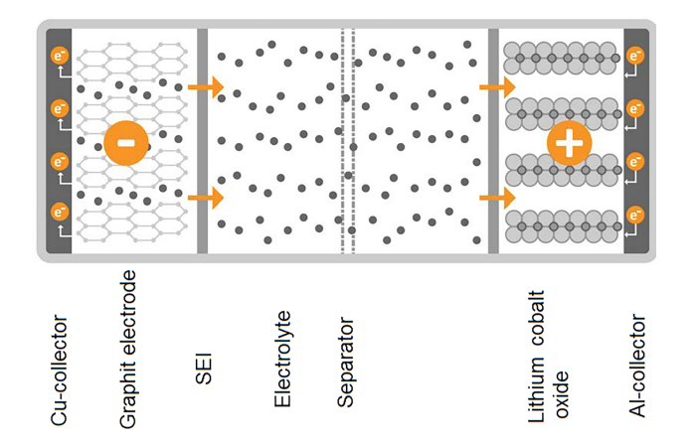

*Figure1: Structure of LIB cell*

In [1] , design of experiments was implemented to analyze the sensitivity of design factors such as electrode and separator thicknesses, porosity, and particle size that directly affect the design variables of LIB important for high specific energy density. Progressive quadratic response surface method (PQRSM) was used to optimize the design variables of the cell to obtain high specific energy output. This method helped optimize the thickness ratio of cell and porosity was reduced to obtain high specific energy density.

In this project, a single objective optimization problem is solved by three different single-objective optimization methods.

* Single objective thermal optimization- Solved using the canned continuous optimization approach that uses Matlab’s optimization toolbox (i.e. fmincon).
* Single objective energy density optimization- Solved using Penalty Method Algorithm implemented in Matlab.
* Single objective energy density optimization- Solved using Excel’s optimization method known as “Solver”.

Following single objective optimization, bi-objective optimization problem is solved by two different optimization methods.

* Bi-objective thermal and energy density optimization- Solved using Excel’s optimization method known as “Solver”.
* Bi-objective thermal and energy density optimization problem- Solved using epsilon method Matlab.

# **2. Problem Definition and Formulation**

## **2.1 Problem Definition**

The two objectives of this project are as follows; maximize the energy density of the lithium ion cell and minimize the cell’s pin temperature (corresponding to the region experiencing highest temperature).

One of the main drawbacks of electric vehicles or other power reliant products transitioning to DC-electric power sources is the low energy density of batteries when compared to fossil fuels. With lithium ion cells having the highest energy density of commercial batteries, they are often the battery of choice for such products. Therefore, it is paramount that the design of lithium ion cells attempts to maximize their energy density. The first project objective attempts to accomplish this through increasing the amount of current that can be generated from the lithium ion cell over the course of a full discharge. As the amount of current produced is directly related to the amount of lithium transferred from one electrode to the other in the discharge process, it may perhaps be better stated the first objective of the project is to maximize the amount of active lithium, the lithium that diffuses from anode to cathode and back, in the cell.

Li-ion batteries must operate under a certain maximum temperature. If the operating temperature exceeds a certain level, the liquid electrolyte in the cell will evaporate [6] and the energy transfer in the cell will be disrupted. Furthermore, higher operating temperatures will cause rapid solid electrolyte interphase (SEI) layer growth risking internal shortage in the battery [7]. Therefore for the effective and long term operation of a li-ion battery cell, maximum temperature reached must remain below a threshold while trying to minimize that temperature to extend the life of the cell.

The optimization of lithium ion cells in this project will be accomplished through a 1D modeling of the lithium ion cell behavior. The design variables chosen to be optimized in order to achieve the project objectives are anode, cathode, and separator thicknesses, as well as anode and cathode porosities. These were selected as a result of a literature review where it was found that these design variables are a common choice of variables in studies attempting to accomplish similar objectives to the objectives of this project. Choosing the same design variables is beneficial as the results of other studies examined in the literature review can act as points of reference after the results of this project are found. The table below gives a list of the design variables with the notation with which they will be referred to henceforth in this report.

|  |  |
| --- | --- |
| X1 | Anode Thickness |
| X2 | Cathode Thickness |
| X3 | Separator Thickness |
| X4 | Anode Porosity |
| X5 | Cathode Porosity |

*Table1: Selected Design Variables*

## **2.2 Assumptions**

One of the first assumptions to be made is that the size of the cell to be optimized will be a standard commercially available size. This will be done to give the parameters of cell height and cell diameter. The three most common sizes of these lithium ion cells on the market are 18650, 20700, and 21700. This project will focus on optimizing the 20700 cell as this size is one that is commonly used in the battery packs of electric vehicles. The size denotation of 20700 means that the cell is 20mm in diameter and 70mm in height.

In a typical lithium ion cell, a single long sheet of the various components that comprise the lithium ion cell (current collectors, anode, separator, and cathode) is assembled and then rolled into a spiral to be placed into the cylindrical cell packaging. A cross section of this configuration can be seen in figure 2. However, this layout adds complications in the computation of volumes of different components as no single consistent radius can be found at any two points of the same rotation, or “layer” of the cell. To alleviate these computational complexities slightly, this project will model the layers of the lithium ion components as concentric circles, as can be seen in figure 3.

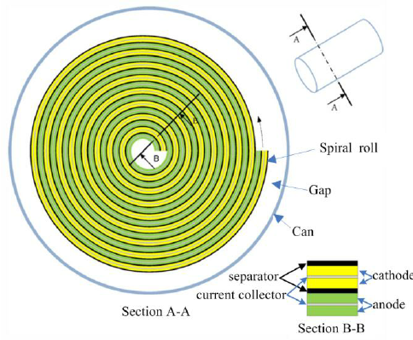

*Figure 2: Spiral Cross section of cell Figure 3: Cross section of cell with layers as concentric circles*

The number of these layers, *S,* will be determined by the layer thickness, a function of the design variables, and the overall battery diameter, a known parameter. More specifically, the number of layers will be calculated by dividing the radius of the battery by the layer thickness, allowing us to maximize the volume of active material in the given cell diameter. Because there needs to be a uniform number of active components in the cell (there would not be an anode without a corresponding cathode), it is assumed that this variable *S* will be restricted to an integer value by means of rounding down to the nearest integer after it is calculated in the method described and shown in the Formulation section of this paper. Because *S* is not an independent design variable, it is not subject to the non-discrete requirements of this project and thus restricting it to integer values is allowable.

The electrochemical process that takes place in a lithium ion cell to enable a potential difference that does not deviate far from its nominal value and the generation of current is an incredibly complex process. The replication of the electrochemical models found in the literature review would result in the objective function taking the form of a series of differential equations, the optimization of which is beyond the scope of what was taught in this course and therefore inappropriate for this project. To simplify the electrochemical model, it is assumed in this project that the current generated by the lithium ion cell over the course of a full discharge is directly proportional to the mass of lithium diffused from the anode to the cathode, a relationship validated by Faraday’s laws of electrolysis.

It will be assumed that only the entirety of the lithium initially in the anode will be the active lithium allowing for the generation of current. It will also be assumed that there is initially no lithium in the cathode and any lithium initially in the electrolyte will remain in the electrolyte. These two assumptions are necessary simplifications to allow for the modeling by Faraday’s law of electrolysis rather than the models found in the literature review. For an example of an issue that would be faced without these assumptions, the lithium concentrations in the electrolyte are modeled in the literature to be functions of the diffusivity rate and concentration distribution. The assumptions made make modeling through Faraday’s laws simpler as they allow for a better accounting of active lithium. Any lithium in the electrolyte will remain there and no initial cathode lithium becomes active after a discharge and subsequent recharge. These assumptions are also made due to the fact that the literature varied in some of the quantities of initial lithium concentrations in the cathode and electrolyte, so this project assumes that these values are zero and constant, respectively.

It will also be assumed that the current collector layer plays no role in thermal or energy density objectives to simplify the problem. Therefore, the current collector layer has a zero thickness and infinite coefficient of thermal conductivity

## **2.3 Formulation**

### **Thermal Optimization**

The thermal conduction path of the cell was assumed to be radial only. This one dimensional path was chosen to reflect the design variables chosen. Although heat is transferred axially, for the purpose of this study, it was assumed to not exist. The radial direction of the cell cross section seen in figure 3 is composed of two regions where heat is generated, anode and cathode, and the separator where no heat is generated. As mentioned before the thickness of the current collector layer is assumed to be zero with infinite thermal conductivity, effectively The conduction path can be simplified further. The path is composed of repeated patterns seen in figure 5.

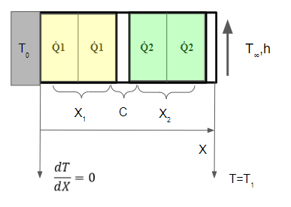

*Figure 5: Repeated pattern in the conduction path*

Heat transfer equation (equation 5) was used to derive a function for temperature at the center pin (seen in figure 5 as T0) which will always have the maximum temperature in the cell by being furthest from the cell surface. It was assumed that there’s no heat flux through the center pin. Each cell is designed to be used in a hypothetical environment with the following external thermal management system. The Cell is being cooled by a coolant with temperature at T∞ Which is assumed to 30C. Coolant is assumed to remove heat at a heat coefficient of 0.9 W/m^2, h. Thermal conductivity of every layer is calculated using equation 1 [4]. Where Rp is the particle size, *li* is the mean free path and is the porosity. Lastly, an equivalent thermal conductivity is calculated based on of every layer.

*Equation 1 Equation 2*

As mentioned before the patterns in figure 4 is repeated S number of times which is a function of cell diameter D, and the layer thicknesses.

Number of layers:

*Equation 3*

After that, surface temperature can be calculated which is a function of heat generated in cathode Q1 and anode Q2.

Surface temperature:

*Equation 4*

Lastly, T can be written as a function of variables previously mentioned [5].

Temperature at centerpin [5]:

*Equation 5*

As a constraint for the thermal formulation, T must remain below 45 degrees celsius [1].

### **Energy Density Optimization**

As the name implies, energy density, or more specifically gravimetric energy density, is the energy capacity of the cell divided by the cell’s weight, giving us the objective function to maximize:

where *Q* is the cell's energy capacity and *Mcell* is the mass of the cell. These two values also need to be solved in terms of the design variable and parameters. As was mentioned in the Assumptions section of this paper, the charge capacity of the cell is directly proportional to the mass of lithium diffused from the anode to cathode over a full discharge cycle. This relationship is given by Faraday’s law of electrolysis which states:

Charge, in coulombs:

where *m* is the mass of the element being diffused, *n* is the valency of the element being diffused (for lithium, *n* = 1), *F* is Faraday’s constant, and *M* is the molar mass of the element. It can be seen that the division of mass by molar mass gives a number of moles of the element being diffused. Although the molar mass of lithium is known, the mass of lithium being diffused is an unknown value that solving for would require knowledge about the mass fraction of lithium in the cell, a value that would be difficult to ascertain. A value that was given throughout the literature reviewed was an initial concentration of lithium in *mol/m3*. Therefore, if a volume can be derived for any component of the cell (anode, cathode, separator, etc), then the moles of lithium in that component can be known using a given concentration. Therefore, the equation for charge can be rewritten as

where *C* is lithium concentration and *V* is volume. The inclusion of porosity is to account for the fact that the anode material does not take up the entirety of the anode volume and the only lithium being assumed to be active is the lithium in the solid state of the anode (not the lithium in the electrolyte in the anode volume). The mass of the cell can be written as

which can be rewritten as

where ⍴ is density and and 𝜖 is porosity. Now all that remains is to derive the equations for volumes in terms of the design variables. It can be seen that the volume of the ith anode has a volume of

where is the inner radius of the ith anode, which can be defined by

Where is the thickness of a single layer, or

Combining equations gives the volume of the anode as

Which simplifies down to

To see the full derivation, please see Appendix I. In a similar manner, the volumes for the other components were found to be

The volumes of the current collectors, both positive and negative, do not need to be calculated as we are assuming the thicknesses of these components to be 0. This also means that in the preceding equations, is equal to 0. The thicknesses and volumes of the current collectors were only included in the preceding equations to give better clarity in the derivation.

In reviewing the literature, constraints were also able to be determined. Firstly, it was seen throughout many of the papers that the maximum lithium concentration allowable in the magnesium oxide cathode was 22,860 mol/m3. Given the assumption that the only active lithium is that which is initially in the anode and the fact that the cathode has no initial lithium concentration, one constraint is

Other constraints found in the literature review are as follows

### **Project Objectives**

The entirety of the project objectives and constraints are summarized below

*Minimize*

*where*

*Subject to*

# **3. Methods, Result and Discussion**

## **3.1 Single Objective**

### Fmincon

Fmincon is a Nonlinear Programming solver provided in MATLAB's Optimization Toolbox. Fmincon performs nonlinear constrained optimization and supports linear and nonlinear constraints.

The fmincon function is:

|  |
| --- |
| [X,FVAL,EXITFLAG,OUTPUT,LAMBDA,GRAD,HESSIAN]  =fmincon(FUN,X0,A,B,Aeq,Beq,LB,UB,NONLCON,OPTIONS) |

Mathematically, this is written as :

|  |
| --- |
|  |

Where b and are vectors, A and are matrices, c(x) and (x) are functions that return vectors, and fun(x) is a function that returns a scalar. fun(x), c(x), and (x) can be nonlinear functions.

In order to perform a single-objective optimization, the aforementioned electrical equations were programmed as a function in Matlab .In parallel, the variable bounds and nonlinear constraints were implemented as functions. The code is available in attachments.Based on fixed parameters, initial values of x0 = [100e-6, 100e-6, 0.3, 0.3, 50e-6], we were able to obtain a maximum energy density of  **85.519 AH/kg (using Fmincon)** with the following values for our variables:

**Using Fmincon**

|  |  |  |
| --- | --- | --- |
|  | Initial Value | Optimized Value |
| Anode Thickness | 100 | 229.2 |
| Cathode Thickness | 100 | 250 |
| Separator Thickness | 50 | 10 |
| Anode Porosity | 30% | 20% |
| Cathode Porosity | 30% | 20% |
| **Energy Density** | **70.83 AH/kg** | **85.519 AH/kg** |

### Penalty Method

Penalty transformation method minimizes the objective functions while maintaining explicit control over the violations of constraints by penalizing the objective at points that violate or tend to violate the constraints.

Consider the problem

A barrier function will then have the following steps:

* Find an interior point . Select a monotonically decreasing sequence for Set .
* At iteration k, minimize the function using as the starting point.
* Perform a convergence test. If the test is not satisfied, set and return to step 2.

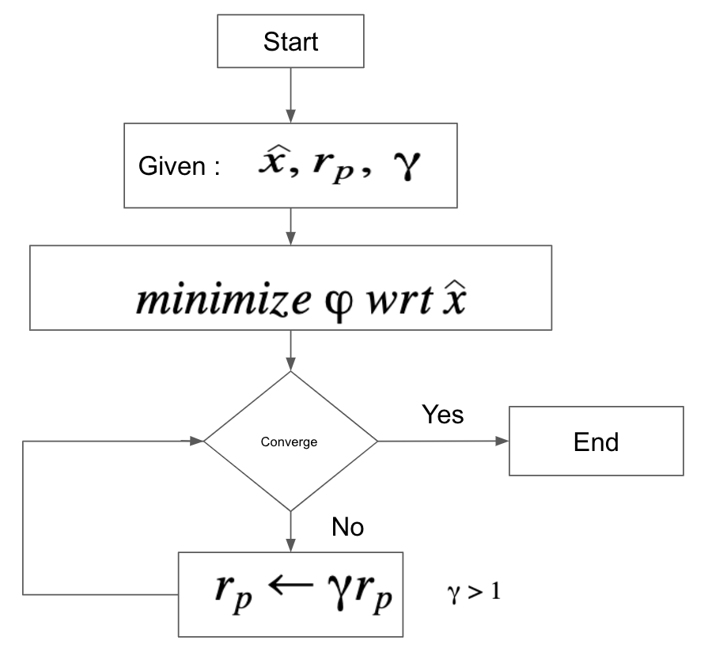

*Figure 6 : Penalty Method: Pseudo code/Flowchart*

In order to perform a single-objective optimization, the aforementioned electrical equations were programmed as a function in Matlab. A penalty method as well as Fmincon was implemented . Based on fixed parameters, initial values of x0 = [100e-6, 100e-6, 0.3, 0.3, 50e-6], we were able to obtain a maximum energy density of **70.28 AH/kg (using Penalty Method)** with the following values for our variables:

**Using Penalty Method**

|  |  |  |
| --- | --- | --- |
|  | Initial Value | Optimized Value |
| Anode Thickness | 100 | 100 |
| Cathode Thickness | 100 | 100 |
| Separator Thickness | 50 | 55 |
| Anode Porosity | 30% | 30% |
| Cathode Porosity | 30% | 30% |
| **Energy Density** | **70.83 AH/kg** | **70.28 AH/kg** |

### Excel

The problem of maximizing energy density was optimized in Microsoft Excel using Excel’s Solver function. This is accomplished through the use of Solver’s GRG Nonlinear optimization algorithm. In its most basic form, this method works based on evaluating gradients at successive points until the gradient of the objective function nears 0 and KKT conditions can be determined to be satisfied. For this project, the multistart function was used with 250 random starting points, so as to hopefully find a solution as close to globally optimal as possible. Pictured below is the sheet that energy density was maximized on, with the optimum values displayed.

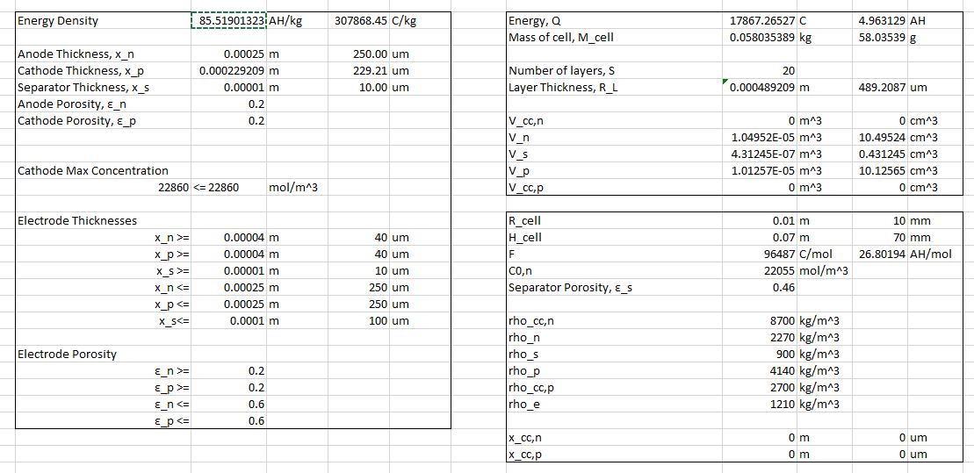

*Figure 7: Single objective optimization sinnept from Excel*

It can be seen in the picture below that the optimum values for the design variables given in the picture above result in a temperature of 39.66 ℃, not violating the constraint set by using the temperature objective function’s maximum allowable value as a constraint.

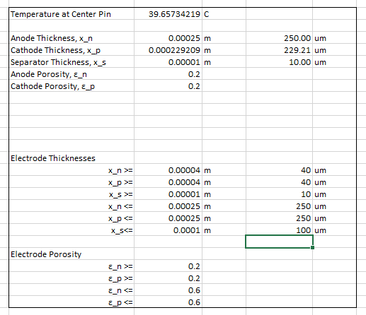

*Figure 8: Optimized values obtained from Excel*

The following table shows the initial values and the optimized values found through Excel’s solver.

Using Excel’s Solver

|  |  |  |
| --- | --- | --- |
|  | Initial Value | Optimized Value |
| Anode Thickness | 100 | 250 |
| Cathode Thickness | 100 | 229.21 |
| Separator Thickness | 50 | 10 |
| Anode Porosity | 0.3 | 0.2 |
| Cathode Porosity | 0.3 | 0.2 |
| **Energy Density** | **70.83 AH/kg** | **85.519 AH/kg** |

### Comparison

Matlab’s Fmincon and Excel’s Solver produced practical and similar results whereas the energy density obtained from the Penalty method was lower than expected. Fminsearch which is a non-derivative based iterative process was implemented in the Penalty method. The iterative process took a long time to converge to the optimized values lying within the feasible region. On the other hand, Single objective optimization involving Fmincon and Excel’s solver were much faster and produced better optimized values of design variables..

## **3.2 Bi-Objective**

### Matlab

Epsilon-constraint method was used to perform the bi-objective optimization and get the pareto frontier. Thermal objective was modeled as a constraint while energy density remained the objective function. During 30 steps, temperature was set to be equal to a value between 39.15 (ideal thermal value) and 51 (nadir thermal value). Figure 9 shows the obtained points.

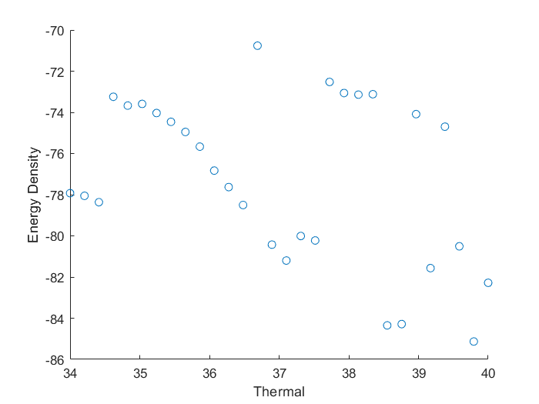

*Figure 9: Epsilon-constraint method optimization.*

In the next step, dominated points were removed from the graph to obtain the true pareto frontier. Figure 10 shows the final results of the bi-objective optimization.

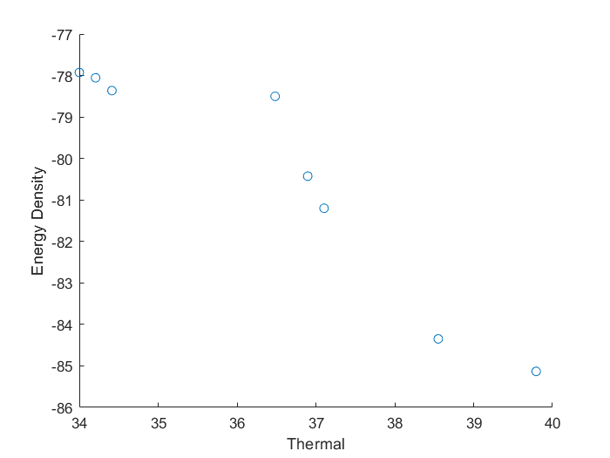

*Figure 10: Final pareto frontier after “cleanup”.*

The obtained frontier then was verified against Matlab’s paretosearch and gamultiobj function under the Global Optimization Toolbox. The following figure shows the frontier generated automatically by Matlab. We are also able to verify our initial assumption that the objectives are conflicting.

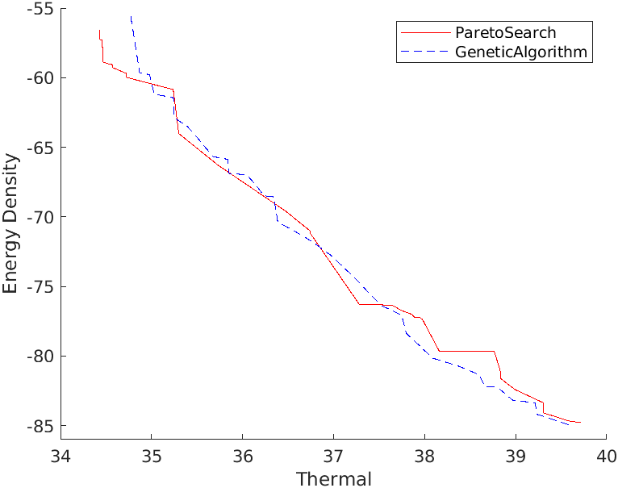

*Figure 11: Matlab global optimization toolbox generated frontier.*

It can be seen that the paretosearch algorithm obtained a similar frontier to the epsilon-constraint method. Both methods show a frontier with steps and relatively flat at high temperature regions.

### Excel

The bi-objective optimization was also solved using Excel’s solver function. This was accomplished through the Weighted Sum Method, where the two objective function values were multiplied by a weight and then added together and the sum of which was the target of Excel’s solver function. Prior to multiplying the objective functions by their respective weights, the values of the objective function were normalized. This was accomplished by finding the minimum and maximum values of each objective function, again using Excel’s solver function and selecting whether to minimize or maximize the target, and then normalizing any value of the objective functions through the following equations

Energy Density

Temperature

Normalization was necessary as the difference in ranges of the two objective functions was great enough that the program almost always favored maximizing energy density over minimizing temperature.

By altering the weights and solving from the same starting point each time, a pareto set was able to be generated, as is shown in the following figures

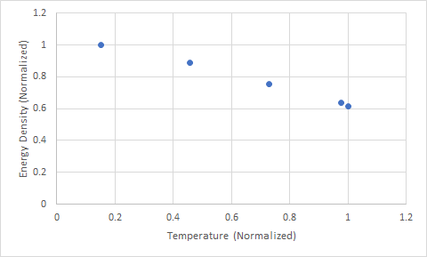

*Figure 12: Normalized Pareto Frontier given by Excel*

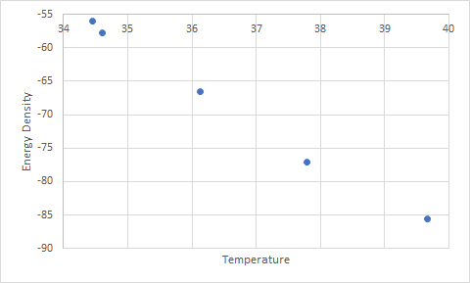

*Figure 13: Pareto Frontier given by Excel*

### Comparison

Both methods were able to produce practical results. However, excel did not have a built-in function for removing dominated points. It was found to be much easier to remove dominated points in Matlab either through a simple script or automatically in Matlab global optimization toolbox. As mentioned in the single-objective comparison section, Matlab is able to produce results much faster than Excel.

Our team decided that a proper trading off point is at a temperature less than 37 degrees and an energy density greater than 75AH/kg. Assigning more weight to the energy density objective.

The following points were obtained from the matlab script.

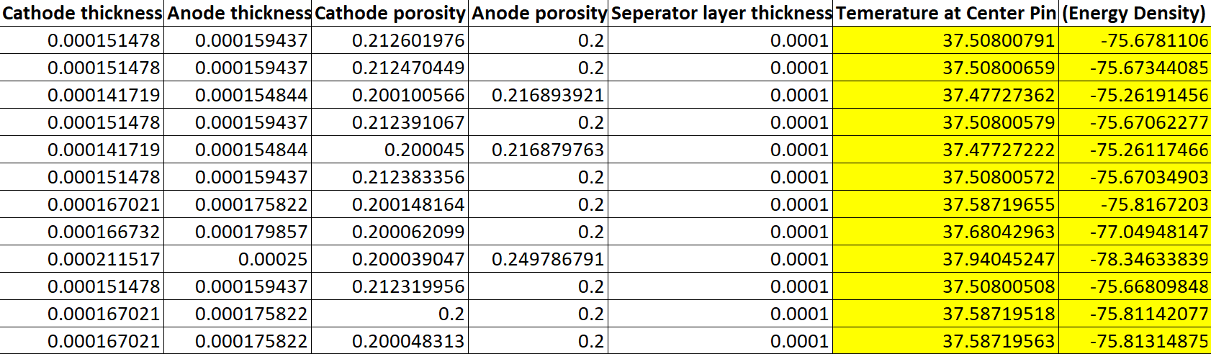

# **4. Parametric Study**

As a part of the parametric study, anode and cathode particle sizes were examined to vary within a certain limit. As seen in the Thermal formulation section, particle sizes affect the layers thermal conductivity in a nonlinear manner. Cathode particle size was varied between 1e-7m and 1e-10m in 50 steps. Similarly anode particle size varied between 2e-7m and 2e-12m in 50 steps. Then, single-objective thermal optimization was performed to minimize cell pin temperature. Lastly, Termal results and particle sizes were normalized. The results can be seen in figure 14.

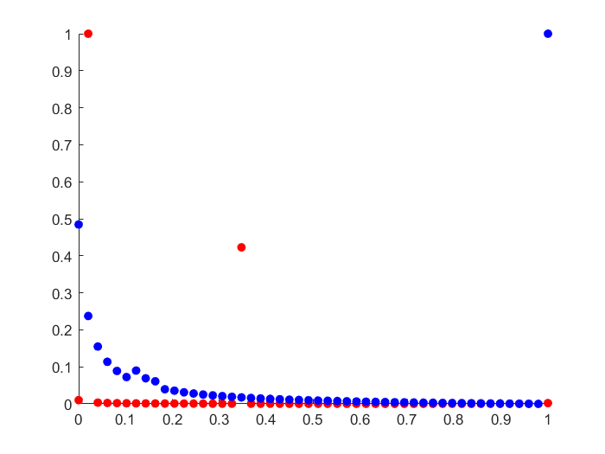

*Figure 14: Cathode particle size in x-axis vs cell pin temperature in y-axis (blue)*

*anode particle size in x-axis vs cell pin temperature in y-axis (red)*

Our model shows that the design is highly sensitive to particle size. A few tens of nanometers can change the center pin temperature by up to 3 degrees C as seen in the following figures.

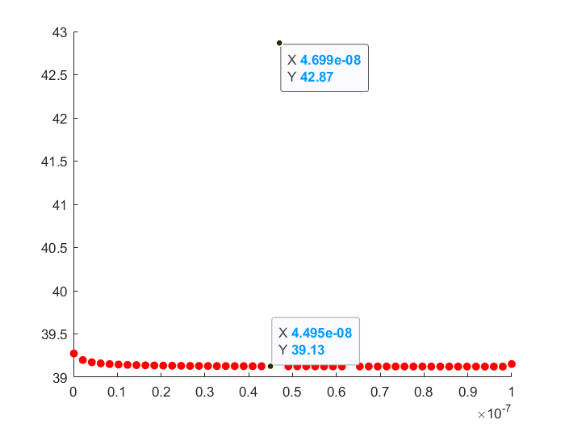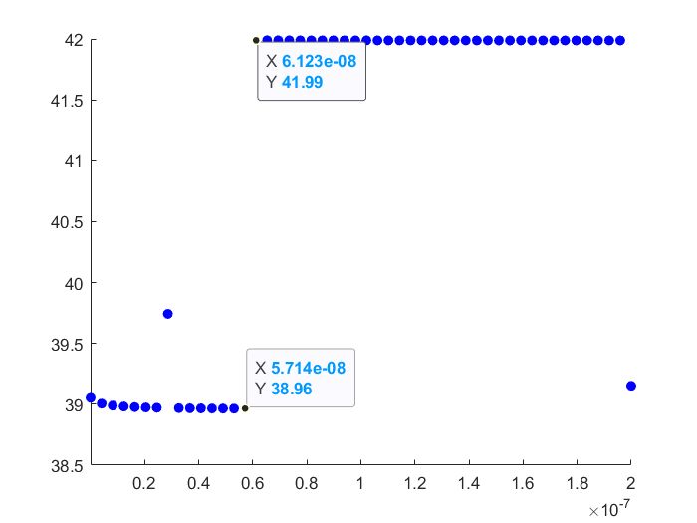*Figure 15: Cathode particle size x-axis vs. temperature y-axis Figure 16: anode particle size x-axis vs. temperature y-axis*

Same parameters were used to perform a parametric study on the bi-objective optimization problem in Matlab. Due to the time needed to run the bi-objective script only four steps were taken to cover the range of the parameter. However, no major variation was observed. Some values of the particle size led to a slightly improved frontier.

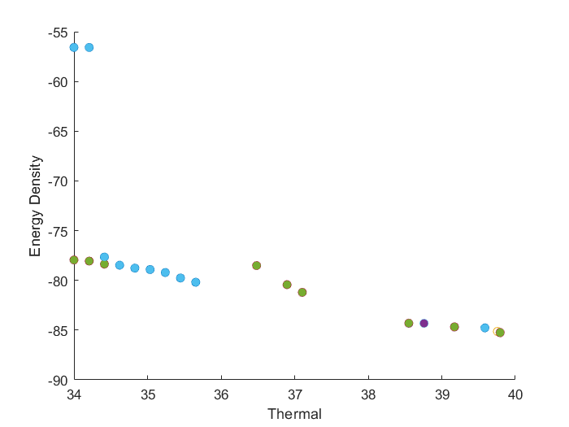

*Figure 17: Cathode particle size*

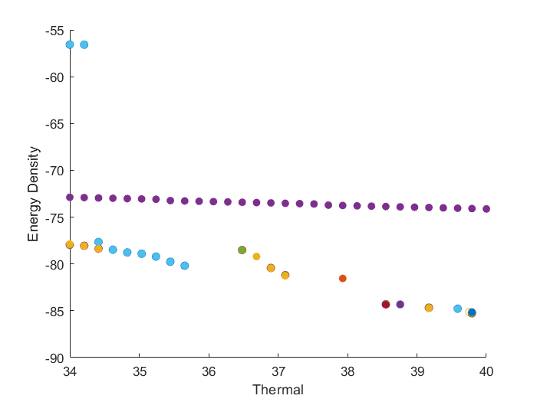

*Figure 18: Anode particle size*

# **5. Conclusion**

In this project, optimization was conducted to maximize the energy density of the cell and minimize the cell pin temperature. First, the design variables were selected and single objective optimization was implemented to maximize the energy density of the cell. Single objective optimization was solved by three different methods, Fmincon from Matlab’s Optimization toolbox, Penalty Method and Excel’s solver function. The result of single objective optimization revealed that Fmincon and Excel’s solver function improved the specific energy density by 18.63%. Next, biobjective optimization was solved in Matlab using the Epsilon-Constraint Method and in Excel using Excel’s solver function implementing the Weighted-Sum method.The result of bi-objective optimization revealed that the paretosearch algorithm obtained a similar frontier to the epsilon-constraint method. Both methods showed a frontier with steps and relatively flat at high temperature regions. Based on our parametric study we suggest adding the particle size to design variables and take a more in depth look into the effects of particle size on the objective functions.

# **6. References**

[1] Kim, J., Lee, D., Lee, J. et al. Optimization for maximum specific energy density of a lithium-ion battery using progressive quadratic response surface method and design of experiments. Sci Rep 10, 15586 (2020). <https://doi.org/10.1038/s41598-020-72442-4>

[2]R. Zhao, J. Liu, and J. Gu, “The effects of electrode thickness on the electrochemical and thermal characteristics of lithium ion battery,” Applied Energy, vol. 139, pp. 220–229, Feb. 2015, doi: 10.1016/j.apenergy.2014.11.051.

[3]B. Suthar, P. W. C. Northrop, D. Rife, and V. R. Subramanian, “Effect of Porosity, Thickness and Tortuosity on Capacity Fade of Anode,” J. Electrochem. Soc., vol. 162, no. 9, pp. A1708–A1717, 2015, doi: 10.1149/2.0061509jes.

[4]Sumirat, I., Ando, Y. & Shimamura, S. Theoretical consideration of the effect of porosity on thermal conductivity of porous materials. *J Porous Mater* 13, 439–443 (2006). https://doi.org/10.1007/s10934-006-8043-0

[5]Brown, A. I., Brown, A. I., & Marco, S. (n.d.). *Introduction to Heat Transfer*. Shaum's Outline Series.

[6] Zhang, Sheng Shui. "A review on the separators of liquid electrolyte Li-ion batteries." *Journal of power sources* 164.1 (2007): 351-364.

[7] Liu, Lin, and Min Zhu. "Modeling of SEI layer growth and electrochemical impedance spectroscopy response using a thermal-electrochemical model of Li-ion batteries." *Ecs Transactions* 61.27 (2014): 43.

# **7. Nomenclature**

|  |  |  |  |
| --- | --- | --- | --- |
| Symbol | Name | Value | Units |
| Design Variables |  |  |  |
|  | Anode Thickness |  | m |
|  | Cathode Thickness |  | m |
|  | Separator Thickness |  | m |
|  | Anode Porosity |  |  |
|  | Cathode Porosity |  |  |
| Parameters and Variables |  |  |  |
|  | Initial Anode Concentration | 22,055 | mol/m3 |
| *D* | Cell Diameter | 0.02 | m |
| *F* | Faraday’s Constant | 96,485 | Coulombs/mole |
|  | Cell Height | 0.07 | m |
| *l* | Mean Free Path |  | m |
|  | Anode | 0.00000003 | m |
|  | Cathode | 0.000000051 | m |
|  | Separator | 0.00000005 | m |
| *m* | Mass |  | kg |
| *M* | Molar Mass |  | kg/mol |
| *n* | Valency |  |  |
| *Q* | Energy |  | Coulombs |
|  | Heat Generated in Cathode | 8 | Joules |
|  | Heat Generated in Anode | 10 | Joules |
| *r* | Radius | 0.01 | m |
|  | Layer Thickness |  | m |
| *Rp* | Particle Size |  | m |
|  | Anode | 0.000000002 | m |
|  | Cathode | 0.00000001 | m |
|  | Separator | 0.000000005 | m |
| *S* | Number of layers |  |  |
| *t* | Thickness |  | m |
|  | Surface Temperature |  | ℃ |
|  | Coolant Temperature | 30 | ℃ |
| *V* | Volume |  | m3 |
| *h* | Heat Transfer Coefficient | 0.09 | W/m^2 |
|  | Porosity |  |  |
|  | Separator Porosity | 0.46 |  |
|  | Thermal Conductivity |  | W/m*K |
|  | Thermal Conductivity with 0% Porosity |  | W/m*K |
|  | Anode | 5 | W/m*K |
|  | Cathode | 10 | W/m*K |
|  | Separator | 20 | W/m*K |
| *⍴* | Density |  | kg/m3 |
|  | Anode | 2,270 | kg/m3 |
|  | Cathode | 4,140 | kg/m3 |
|  | Separator | 900 | kg/m3 |
|  | Electrolyte | 1,210 | kg/m3 |
|  |  |  |  |
| Subscripts |  |  |  |
| *cc,n* | Negative Current Collector |  |  |
| cc,p | Positive Current Collector |  |  |
| *e* | Electrolyte |  |  |
| n | Anode |  |  |
| p | Cathode |  |  |
| *s* | Separator |  |  |

# **Appendix I.**

# Derivation of Anode Volume

# 

# 